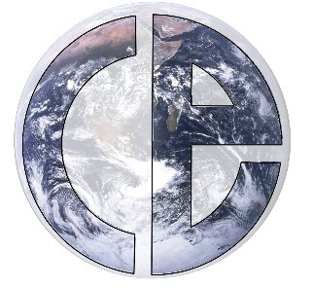
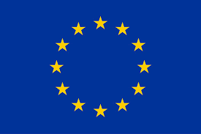
Press release

Climate tipping: West Antarctica ice sheet collapse may stabilise northern ocean currents

(Written by journalist Henrik Prætorius: praetoriushenrik@gmail.com)

If the ice sheet of West Antarctica breaks down, the result can be a stabilisation of the Atlantic ocean current system transporting warm water to the coasts of Western Europe

It has been hypothesised, that the tipping of one element of the Earth’s system can catalyse the tipping of others in a cascade. A new study gives an example of an alternative option, in which the collapse of one component might in fact make another system tipping less likely. In particular, the study indicates that tipping of the West Antarctica ice sheet may stabilise the important ocean current system, called the AMOC, distributing heat to the North Atlantic region. The work by PhD candidate Sacha Sinet and colleagues from the Institute for Marine and Atmospheric research Utrecht, Utrecht University, the Netherlands, is published in Geophysical Research Letters (GRL). The study is part of CriticalEarth, a Marie Skłodowska-Curie Actions - Innovative Training Network (ITN) programme for young scientists led by a consortium of 11 research partners and coordinated by the University of Copenhagen.

Global consequences

”This is a possibility that has to be explored. We need to have a better understanding of the interaction between West Antarctica and the Atlantic ocean currents to build a complete picture of possible outcomes,” says Sacha Sinet, the lead author of the GRL article AMOC Stabilization under the Interaction with Tipping Polar Ice Sheets.

The North Atlantic ocean current system known as the Atlantic Meridional Overturning Circulation, AMOC for short, can potentially tip in the event of a sudden melting (collapse) of the Greenland ice sheet. This is because the existence of the AMOC depends on the formation of dense, salt water in the surface areas around Greenland and Iceland. Large, and sudden amounts of fresh meltwater from the Greenland ice sheet dilute the seawater. Eventually, a tipping point can be reached and the AMOC slows down or might even stop.

An abrupt change of the AMOC would have serious consequences for the global climate system. This system of ocean currents distributes heat to the northern hemisphere. Without the AMOC, the climate in the Northern Atlantic region will abruptly cool. Precipitation patterns and wind systems will be affected on a large scale. In a cascading fashion, this transition could be a trigger for the collapse of other crucial climate components.

Cascade avoided

Now, however, Sinet and colleagues describe that such a cascading tipping scenario might be avoided if the ice sheets of West Antarctica likewise commit to an abrupt melting.

In a conceptual model of the interaction of three climate-sub-systems (the AMOC, the Greenland ice sheet, and the West Antarctica ice sheet), a timely collapse of the WAIS can maintain the AMOC against the destabilisation induced by the Greenland Ice sheet melting and global warming. There, rather than being a set of dominos tipping each other, the fall of one can hinder the fall of another.

”I am still very worried about cascading. At our level of understanding, many outcomes are still possible. Also, remember that, anyhow, the loss of such climate components is a catastrophe. We still lose Greenland and West Antarctica and commit to a drastic rise of sea level. There will be dramatic consequences for our societies and ecosystems,” says Sinet.

”So, whatever the end result, it is still a dramatic event. First, we must do all we can to prevent any from happening.”

CriticalEarth is a Marie Skłodowska-Curie Actions - Innovative Training Network programme for young scientists, 15 PhD international students at 17 European research institutions study and develop the mathematical understanding of tipping points and abrupt climate change.
Additional project information can be found at www.criticalearth.eu
Sacha Sinet: s.a.m.sinet@uu.nl
Anna von der Heydt: A.S.vonderHeydt@uu.nl
Henk Dijkstra: H.A.Dijkstra@uu.nl
…........................


